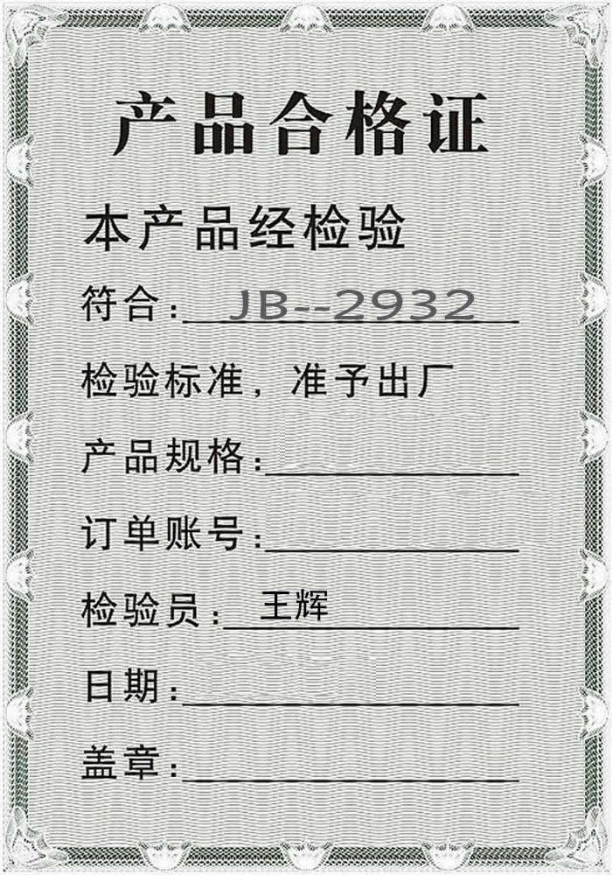
GQHXT-1000
GQSYS-2015-526
2015-05-26

